` 



Numerical Methods in Chemical Engineering

**CLL113**



**PLOTTING INDIA’S POPULATION TOTALS USING LAGRANGE POLYNOMIAL**



**SUPERVISOR**:

Prof. Jayati Sarkar

**AUTHORS:**

Abhijeet Gautam (2020CH10069)

Sonu Kumar (2020CH10133)

Kartik Muradia (2020CH10092)

Sodasani Phani Kumar (2020CH10132)

Abstract

The Population is a critical way to access the developments of people. Thus, Population was quite possibly one of the most indispensable contributory elements in the early advancement of western countries. India is the second-largest country on the planet in terms of Population, having 2.4% of worldwide land and 17.5% of the world's absolute Population. The fast population development of India brings about winning high rates of birth and a huge decrease in the death rate in our country. Unexpected expanding Population and constant mortality rate improvement likewise caused genuine natural corruption in India. Schooling assumes a vital part to control the population development in our country. A polynomial dependent on Lagrange polynomial is proposed, which will help interpolate the population curve, Horvitz Thompson and proportion assessors, this procedure depends on yearly Population to fit in the best approximating polynomial inside a given timeframe (a long time) from 1950- 2050. This proposed procedure has been demonstrated to be fair under a polynomial. Hence, the current paper manages the general examination of Indian Population and its maxima and the causes and effects of Population in India's context of social and economic development.

Keyword

Population, Indian Population explosion, Maxima of the population Curve, Lagrange Analysis, Approximation, birth rate, mortality rate,

Introduction

The population growth in the world is dramatically exponential, especially in our country India, with the number of inhabitants doubling from 3 to 6 billion between 1960 and 2020. Several studies suggest that India will surpass China to become the most populated nation globally, soon. India has seen rapid population growth since 1960. The main focus of this project is to plot the Indian Population using Lagrange Interpolation Polynomial.

Figure 1 plots world Population from 1950 to 2050, and shows the share of world population attributable to India; post-2010 data are United Nations (UN) projections.

# Figure 1

**India’s share of world population**

10

9

8

7

**Population (billions)**

6

5

4

3

2

1

0

1950

1975 2000

2025 2050

India Rest of World

*Source: United Nations (2009).*

Global Population grew at roughly 2% per annum from 1960-2000, a level that is unsustainable in the long term, as it translates into Population doubling every 35 years. India’s population is currently growing at a rate of 1.4% per year, far surpassing China’s rate of 0.7%.

Studies suggest that this increase in Population will result in India surpassing China concerning population size in less than 20 years.

Problem Formulation

Given (n+1) data points (x0, y0), (x1, y1), (x2,y2), …(xn, yn), we are required to fit a polynomial curve which passes through these (n+1) points and can be used to interpolate the value at any given **x**.

Our problem consists of population data for 1960, 1970, … 2020. We are required to estimate the Population of India at any given year in the range [1960, 2020]. Also, we have to plot the population curve from 1960 till 2020.

***Note:*** *The population data is obtained from the World Bank website (reference at the end)*

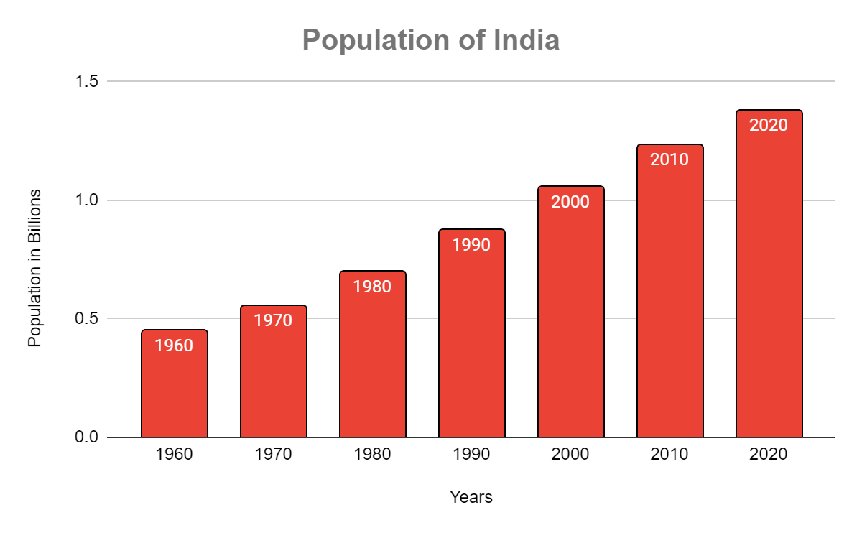

*(Population data points given to us)*

Mathematical Calculations

We will be using Lagrange Polynomial interpolation as a mathematical method to fit a graph on the data points and find the unknown data.

There is only one polynomial for n+1 data points, which passes through all those points and is of order n. And determination of such a polynomial is called polynomial interpolation.

One such form for expressing an interpolating polynomial is Lagrange Interpolating Polynomials.

A Lagrange Polynomial is a way to find a polynomial of n degree which passes through (n+1) data points by avoiding computation of divided differences. It is represented as follows:

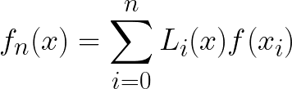

where,

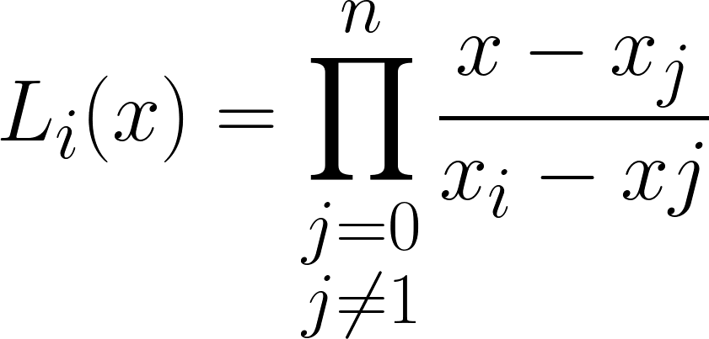

and {\displaystyle \prod } signifies “product of”. For instance, at n=1, the first order version is

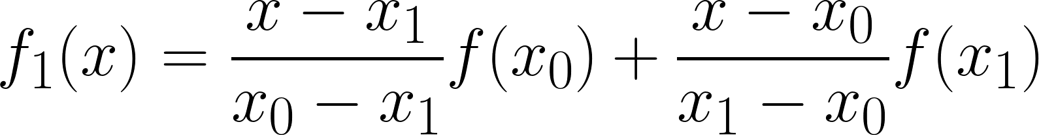

and similarly, the second order version is

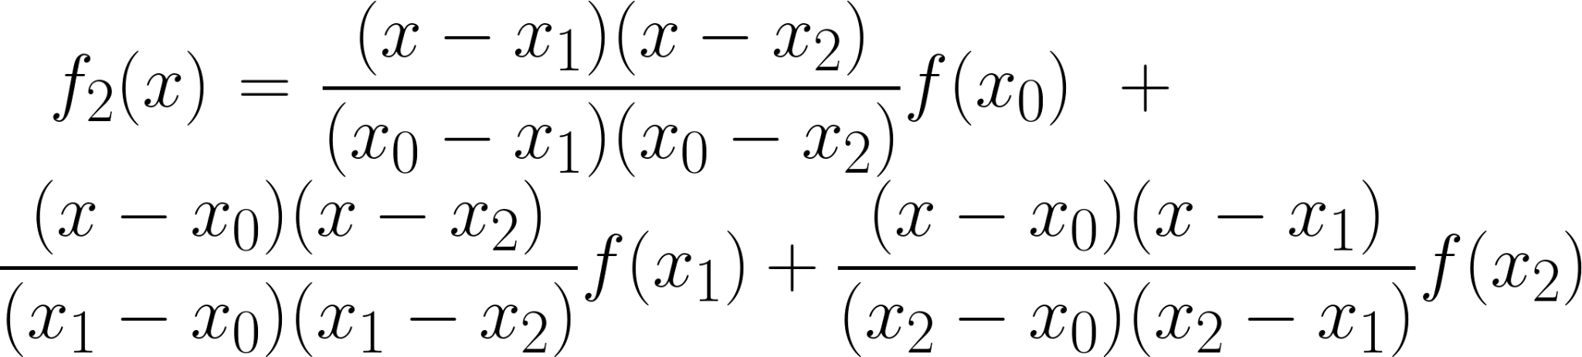

With the help of this we will be finding other unknown data points and can also be used to approximate the Population in the upcoming years.

The C++ program attached with the term paper is designed to perform such recurring calculations and obtain the population estimate at any given year. The complete polynomial curve is obtained in the next section.

Formation of the Lagrange polynomial

Lagrange polynomial interpolation provides the estimated Population of India at any given intermediate year. However, this method is unable to provide an algebraic polynomial which can be represented as the curve which passes through all the data points. Therefore, one more objective is to present the Population at any given year through a polynomial f(x). A polynomial makes it easier to analyze other aspects such as the maximum and minimum Population in the history of India (in the given range of years).

So, we can assume the interpolating polynomial of the form

fn(x) = a0 + a1x1 + a2x2 + …anxn

For obtaining (n+1) coefficients [a0, a1 …an], we need (n+1) equations which can be simultaneously solved.

We have (n+1) data points: (x0, y0), (x1, y1), (x2,y2), …(xn, yn)

Substituting the data points, we get (n+1) equations

y0 = a0 + a1x01 + a2x02 + …a6x06

y1 = a0 + a1x11 + a2x12 + …a6x16 …so on

For simplicity we assume x0 = 1 (rather than 1960), x1 = 2 (rather than 1970) … and so on

Now we can solve the system of 7 equations to obtain 7 unknown coefficients [a0, a1 …an].

Let **X** be 7th order square matrix: **Xij = (xi-1)j** where i,j Є [0,6]. For simplicity, the **x**-values are chosen to be 1,2...7 (rather than 1960, 1970 … 2020).

The **y-values** can be represented by a (**7×**1) matrix: **Y = yi** where i Є [0,6].

The coefficient matrix: **A** **= X-1Y**

*(The calculations are done in the Excel sheet provided with the term paper)*

We obtain the following results

a0 = 0.32159707 a1 =0.1985207152 a2 =-0.116234662

a3 =0.05792229498 a4 =-0.01250552683 a5 =0.001301816838

a6 =-0.00005403320139

Therefore, now the complete representation of population from the year 1960 to 2020 can be done using a single polynomial f6(x) = a0 + a1x1 + a2x2 + …a6x6 where all the coefficients are known. The following graph shows the population curve of India.

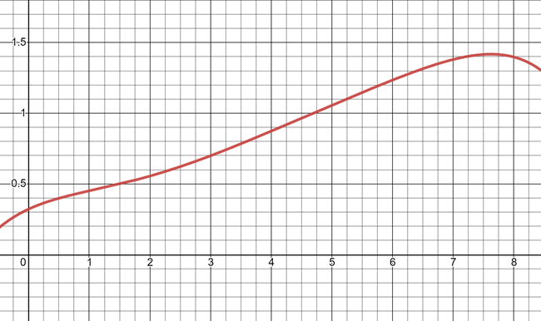

Population in Billions

**1980**

**1970**

**1960**

**1990**

**2000**

**2010**

**2020**

*(****Note:*** *The Horizontal Axis consists of the years 1960, 1970…2020 which are denoted by 1,2…7 respectively for convenience.)*

Error Analysis

The Lagrange Interpolation method proves to be decently accurate in interpolating the Population in intermediate years (between 1960 to 2020). Moreover, the error is the least when the required **year** (Population of which is to be estimated) is near the middle of the range. The following are the True Relative Errors (in %) for some of the sample input **years**:

**Year 1974**: 0.1839919884 % *(year far away from the middle)*

**Year 1992**: 0.05227431336 % *(year towards the middle)*

**Year 2005**: 0.05203466679 % *(year towards the middle)*

**Year 2018**: 0.2747374562 % *(year far away from the middle)*

*(****Note:*** *The true values of Population are taken from the World Bank website [reference at the end]).*

Observations

1. From the population curve f6(x) we can observe that the Population of India has been on a steady rise since 1960 and is the maximum in 2020 till now. Also, experts believe that the Indian Population would surge more and India would surpass China to be the most populated country in the world. Although the Lagrange polynomial is successful in estimating the Population in the years between the given range, it is unable to predict or extrapolate the Population in the coming years. Predicting Population in the coming years would be of great importance to the medical, agricultural and economic institutions of India for sustainability of resources. With our existing knowledge of *numerical methods*, we were unable to generate a technique or method to extrapolate the Population to further years.
2. Comparatively lower errors are observed when the required **year** (Population of which is obtained) lies near to the middle of the range [1960, 2020]. On the other hand, high errors are obtained when the required **year** is towards the extreme points.
3. The Lagrange polynomial gives absurd results on extrapolation (predicting the values outside the given range). Therefore, we limited our term paper to the interpolation only.

Conclusion

This Project proves that Lagrange interpolation is a good way in approximating data and to get approximately unknown values. As the data, the Population of India from (1960 - 2020) collected from different sources are used as interpolating points and after doing the mathematical analysis we can find the Population at any stage. The accuracy and precision of this technique can be better measured with the outcome in addition to that the polynomial could also be extrapolated to find the Population in the coming years and then compare it with the exact Population obtained in the census.

Thus, we can conclude that any nation’s economic and social progress is

Highly dependent on its Population. From the census reports we gather that India has already experienced population explosion, the causes are: -

1. Decline in Death Rate.
2. Better medical Facilities.
3. Wrong notions more hands will help overcome poverty.
4. Technological advancement in medical science.
5. Lack of proper Education and Family Planning.

Self-Assessment

In this term report, we used the Lagrange Interpolation Polynomial method to interpolate between a given set of data points. This observation can be useful for estimating the needs and growth of the nation on account of its historical data. We wrote C++ codes for the polynomial interpolation as well as Excel Sheet for obtaining the coefficients of the Lagrange polynomial. Moreover, we established the population curve which represents the population data from 1960 to 2020 in a single graph.

We consider our term report to be **LEVEL-1** since we were successful in reproducing the results of population data but could not extend our establishment to extrapolate the data and predict the Population in future.

References

1. ‘Numerical Methods for Engineers’ *by Steven C. Chapra & Raymond P. Canale*
2. World Bank website for population data of India: <https://data.worldbank.org/indicator/SP.POP.TOTL?locations=IN>
3. Lagrange’s Interpolation Formula: Representation of Numerical Data by a Polynomial curve: <https://www.researchgate.net/publication/307867699_Lagrange's_Interpolation_Formula_Representation_of_Numerical_Data_by_a_Polynomial_curve>
4. Size, growth rate and distribution of Population (Census India): <https://censusindia.gov.in/2011-prov-results/data_files/india/final_ppt_2011_chapter3.pdf>